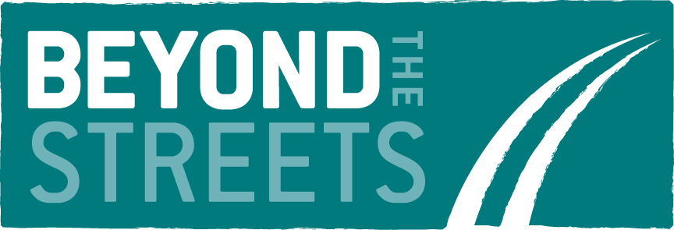

VOLUNTEER APPLICATION FORM
Thank you for your interest in volunteering with Beyond the Streets for the Door of Hope project. This application form has been designed to help us match your abilities, skills and experience to the most suitable volunteer opportunity within the charity. The information you provide will be treated with the strictest confidence and will only be seen by members of the team involved in the appointment and supervision of volunteers.

 | Role Applying for: |  | X
 | Women’s Support Volunteer
 |  | Outreach Worker

PERSONAL DETAILS
Title and full name |  |  | DoB
Address |  |  | Tel
 |  |  | Mobile
 |  |  | Email

CURRENT/MOST RECENT EMPLOYMENT DETAILS
Employer’s name |  |  | Dates employed
Address |  |  | Job title
 |  |  | Brief description of responsibilities

PREVIOUS EMPLOYMENT/ VOLUNTEER HISTORY
Dates from and to | Employer | Position held | Reasons for leaving

QUALIFICATIONS
Qualification | Awarding body | Date awarded
VOLUNTEERING FOR THE DOOR OF HOPE PROJECT
Why would you like to volunteer with Beyond the Streets?
What are your hopes and expectations in volunteering?
Do you have any previous experience in the women’s sector or with vulnerable adults? If yes, please provide brief details below and describe your experience in this work. This can include volunteer experience.
Please look at the requirements for the role you are applying for and the main tasks of the role description. What skills, qualities or attributes not mentioned above do you feel you have which would enable you to fulfil the requirements of the volunteer role? Please provide brief details below.
Our charitable aims, ethos and values are outlined in the Volunteer Application Pack. We are looking to recruit volunteers who can work positively within our aims, ethos and values. Please reflect on these and explain how you see yourself working within these values?
The time commitments for each role are outlined in the role descriptions in the Volunteer Information Pack. Can you confirm you have availability to commit to this?
Interview dates for each role are included in the Volunteer Information Pack, please advise us on which dates you are available for interview and any time restrictions.

Self-Declaration and Disclosure Form

Private and Confidential

For roles involving contact with children (under 18 year olds) or vulnerable adults.

NOTE:
If the role you are in or have applied for involves frequent or regular contact with or responsibility for children you will also be required to provide a valid DBS (Disclosure and Barring Service) certificate which will provide details of criminal convictions; this may also include a Barring List check depending on the nature of the role (see organisational guidance about eligibility for DBS checks).

Have you ever been known to any Children’s Services department or Police as being a risk or potential risk to children? If working with vulnerable adults have you ever been known to Adults Services or Police as being a risk or potential risk to vulnerable adults? |  | YES / NO  (if Yes, provide information below):
Have you been the subject of any disciplinary investigation and/or sanction by any organisation due to concerns about your behaviour towards children or vulnerable adults? |  | YES / NO  (if Yes, provide information below):
Confirmation of Declaration
I agree that the information provided here may be processed in connection with recruitment purposes and I understand that an offer of a volunteering role may be withdrawn or disciplinary action may be taken if information is not disclosed by me and subsequently come to the organisation’s attention. |  | YES / NO
In accordance with the organisation’s procedures if required I agree to provide a valid DBS certificate and consent to the organisation clarifying any information provided on the disclosure with the agencies providing it. |  | YES / NO
I agree to inform the organisation within 24 hours if I am subsequently investigated by any agency or organisation in relation to concerns about my behaviour towards children or young people. |  | YES / NO
I understand that the information contained on this form, the results of the DBS check and information supplied by third parties may be supplied by the organisation to other persons or organisations in circumstances where this is considered necessary to safeguard children. |  | YES / NO
Signature:

Print name:

Date:

REFERENCES
Please provide below details of two people we can approach for a reference. They should have known you for at least two years, and ideally be an employer, a minister of religion or any other reputable person. They should not be a family member or a person with whom you live.

Due to the nature of our work, and to help us ensure your wellbeing, we also require that one referee is someone able to provide you with pastoral support during your time with Beyond the Streets, for example, this could be a mentor, a pastor of a church or a minister of religion. This is to ensure the appropriate support should you face any challenges that you wish to reflect on with someone external to Beyond the Streets.

Referee
Title and name
Address |  |  | Tel
 |  |  | Email

Referee
Title and name
Address |  |  | Tel
 |  |  | Email

DECLARATION

The information provided in this form is accurate to the best of my knowledge.

Signed | Date

NEXT STEPS
- Please return this form by email to doorofhope@beyondthestreets.org.uk by midnight on 2nd August 2018.
- We will review your application form and contact you to arrange an informal interview so that you can meet the team and find out more about what we do. Interview dates are included in the Volunteer Information Pack, please provisionally keep a selection of dates free for interview.
- If we feel we do not currently have a suitable volunteer opportunity to match your application, we will write to let you know.
- Your acceptance to join the team is conditional on you attending compulsory training sessions relevant to your role - these are included in the Volunteer Information Pack, please check you are free on these dates before applying.
- Please note we are a small team of staff, it may take us a few days to get back to you.
- We will take out references and may ask you to complete a DBS check.
- You will be invited to attend an induction and training session prior to commencing your volunteer role.

